**BUSM1311**

**The Entrepreneurial Process**

**Semester 1, 2020**

**Assignment 3 – Entrepreneurial Process Analysis**

**Name:** Duncan Do

**Student Number:** s3718718

**Contents Page**

|  |  |
| --- | --- |
| Cover Page | 1 |
| Contents Page  The Entrepreneur  The Entrepreneurial Mindset  Ethical Dilemmas  The Pathway  Innovation  Opportunities  Funding  Conclusion  References | 2  3  4  6  7  7  8  8  9 |

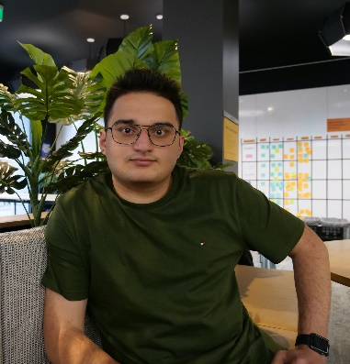**The Entrepreneur**

RMIT University student andbudding entrepreneur Shahryar Faraji, is the CEO and founder of 1receipt. A mobile application that aims to digitise receipts into a user’s phone, allowing the shopper to obtain a digital receipt while maintain privacy over their shopping expenses, and reducing the paper waste (for receipts) of retailers.

Shahryar conceived this idea while observing countless shoppers throw away large quantities of paper (the receipts) after every shopping excursion. This inspired Shahryar to research a way to

“*prevent wasting such a valuable resource”*

*“reduce retailers’ cost for issuing paper receipts”*

*“Make shoppers’ life even easier for storing/retrieving their shopping receipts without revealing their personal information*”

These three statements form the fundamental goals of Shahryar and 1receipt.

Faraji set out to develop a user cantered system for obtaining and retaining digital receipts. making shoppers’ life even easier for storing/retrieving their shopping receipts without revealing their personal information. Furthermore, the app also provides a feasible long-term storage for GST and other tax purposes – a task practically impossible due to the maximum one-year life span of the thermal paper receipts.

**The Entrepreneurial Mindset**

Faraji’s entrepreneurial direction bares resemblance to Frank Knight’s interpretation the entrepreneurial process. In Knight’s 1921 publication of *Risk, Uncertainty and Profit,* he makes the important distinction that “*profit—earned by the*[*entrepreneur*](https://www.merriam-webster.com/dictionary/entrepreneur)*who makes decisions in an uncertain environment—is the entrepreneur’s reward for bearing uninsurable*[*risk*](https://www.britannica.com/topic/risk-finance)” [1].

An interpretation of this can be extrapolated from the work of Faraji with 1receipt. In a society seemingly apathetic to waste, seen in Faraji’s own observation of everyday shoppers as well as global/national statistics, it is innately a risk to introduce a new system that goes against the established status quo of our society, the uncertain environment.

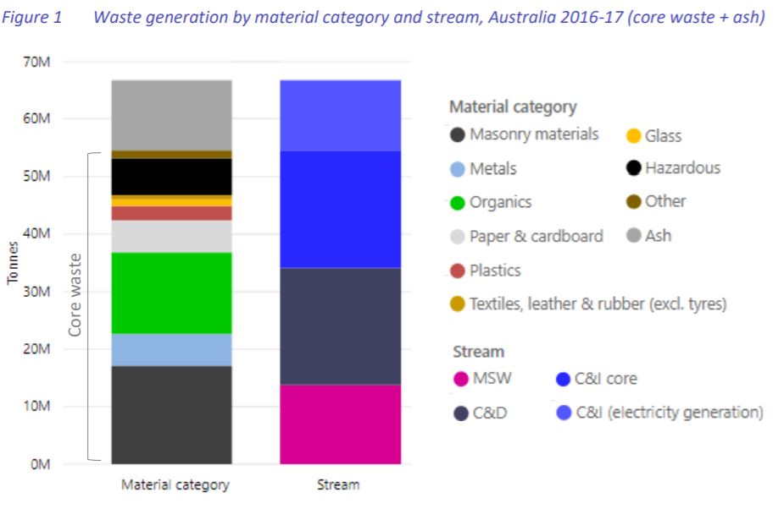[2] Approximately 5 Million tonnes of paper related waste

This risk being the unimportance of common waste such as paper (receipts). Similar action can be observed through the success of applications such as uber and Airbnb. New services that challenge pre-existing services in modern society. All the aforementioned services, including Faraji’s take inspiration from Frank Knight’s idea of disrupting the current status quo of the industry. The infamy of Knight’s work and the success of apps like Uber suggests that this is an effective model to follow.

Faraji’s reasons for beginning this entrepreneurial venture help classify him as an opportunity-driven entrepreneur and a in some ways, a social entrepreneur.

He is an opportunity-driven entrepreneur in how he “*perceive*(d) *an unexploited (or underexploited) business opportunity in the market”*[3]. He voluntarily created a venture out of his own curiosity and ambition to solve the issues he identified, rather than venturing out for any necessity reason. Further evidence to place Faraji in this category of entrepreneurship, is his self-admitted desire for *“Independence and unleashing creating to solve real world problem”*. A key attribute of opportunity-driven entrepreneur is their desire to create their income out of their own independent activity.

Furthermore, beyond Faraji’s personal reasoning to becoming an entrepreneur, 1receipt was created to “*solve* [the] *real world problem”* surrounding paper waste. While this driving factor is only one of many reasons for 1receipts creation, its existence alone connects Faraji’s endeavours to social entrepreneurship. One of the goals of 1receipt is to reduce the environmental impact that receipts have, being the amount of deforestation required to produce them. Thus, 1receipts commitment to reducing environmental harm allows it to be classified as a social venture in that regard.

Faraji displays many qualities and skills that exemplify his entrepreneurial mindset. The creation of 1receipt alone demonstrates his ability to innovate and create creating solutions to problems in our society. Furthermore, he clearly identifies the goals for his venture; allowing him to plan and act accordingly to meet those goals (Listed in the “The Entrepreneur” section of the report).

Ethical Dilemmas

While Faraji has not come across or identified any ethical dilemmas in his business venture so far; the disruptive nature of 1receipt to its existing counterpart services provides the dilemma of putting those said services in jeopardy. However, in this instance, the dilemma is softened due to the negative connotations attached to what 1receipt is trying to replace. That being paper receipts, which are a huge contributor to environmental harm (creation and waste), and financial waste.

**The Pathway**

From the list of different pathways to entrepreneurship. Faraji utilised “bootstrapping” and “business assisted funding”. Following these two pathways allowed Faraji to acquire a large amount of assistance in the early days of his venture in many forms.

Rather than starting from complete scratch, Faraji facilitated his “company's start-up and growth with the assistance of or input from others” [4]. He was resourceful and acquired multiple online bootstrap applications for the services needed for 1receipt. This allowed him to get a technical demo of the application quickly. Furthermore, to further assist his business in the start-up phases, Faraji enlisted the help of RMIT Activator. The Activator “*cultivates an entrepreneurial mindset among the RMIT community and support venture creation and growth*” [5]. A mentor like service that assists budding entrepreneurs to get their foot in the market.

Faraji further expanded on the idea of bootstrapping and business assistance in a financial capacity. The Activator not only supplied Faraji with insightful tips and mentorship, but also provided him with an initial start up investment to allow him to begin.

1receipt followed an iterative process of concept, ideation, prototyping and feedback. This loop allows 1receipt to constantly update and improve upon itself with the requirements of the consumers in mind.

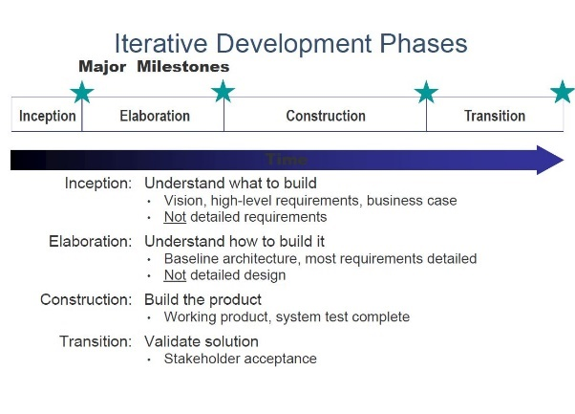

[6] Iterative Development Phases

**Innovation**

1receipt offers a dynamic and completely unique service that comes with countless benefits for both retailers and shoppers. Instead of helping *one* group of people, it benefits *everyone*. Furthermore retailers can save money by going digital while shoppers can keep their information safe and ultimately save their time.

The unique aspect of 1recepit is its ability to evolve on the current system in a way that benefits both major parties while simultaneously helping a social goal.

The current standard of emailing or text messaging receipts is an ineffective way to eliminate paper receipts. In response, 1receipt cut eliminated the need to give personal information for digital receipts, allowing them the same functionality with better security, an enhancement on the old system.

1recpet theoretically eliminated the need for an entire service and offered a brand new one with improvements both in the experience and the practicality.

**Opportunities**

Faraji capitalised on an untapped corner of the market. Adapting an existing system to better suit the needs of the people and society.

Furthermore, Faraji discovers a social-culture opportunity by putting the shopper/user in the position of power, thus using 1receipt gives the user a better sense of security that their information is not shared to the retailer at checkout.

1recepit also taps into an economic opportunity by attacking the $350,000,000 paper receipt issuing cost for major retailers in Australia alone [7].

Holistically, by creating 1recept, Faraji tapped into the technological opportunity to digitise a common service in modern society to improve it in ways that benefit both parties.

In addition to this, when looking at the environmental factor, Faraji found an opportunity to lessen environmental damage (deforestation for paper) without hindering the service (Getting receipts).

Opportunity categorisation and analysis sourced from [8]

**Funding**

1receipts support came from very few sources. Beyond Faraji’s own personal financial backing, 1recept funding solely comes from the RMIT Activator’s investment. Which links back to the bootstrap and business assisted funding route that Faraji took his entrepreneurial venture. Any future financial resources will have to come from consumers or future investors. The 2 pathways Faraji adapted (Bootstrap and Business assisted funding) for 1recept allowed him to move through the beginning phases of his venture with little financial trouble as most was supplied and other expenses on technological services were bootstrapped from online resources.

**Conclusion**

Holistically, Shahryar Faraji has done an excellent job conceiving, planning, and executing his entrepreneurial venture thus far. However, nothing is perfect and there are ways that this venture could have been improved upon in hindsight.

The first would be to involve the users for customer feedback earlier in on in the venture, particularly in the requirement gathering phase and beginning iterations of the application back in alpha phase. As said by Faraji himself, he wishes he had gained customer insight before building anything. “*Risks are reduced by identifying all key requirements*” [9] from the key demographics. With the user requirements properly identified, it would give a clearer indication of what the build needs to be able to do (Build to fulfil).

Secondly, a more social push needs to be made to put 1receipts name out to the public. Besides investors and alpha/beta testers, 1receipt is fairly unknown. In order to get social traction and attract potential investors, 1recept needs to be known. “*Social platforms allow [companies] to interact with existing and prospective investors and analysts, control messaging, and increase traffic to companies’ corporate websites”* [10]. This would help with the funding of the venture as a whole. While the assisted funding from RMIT Activator has sustained Faraji’s venture so far, the opportunities that could be possible with extra funding could greatly assist 1receipt.

Beyond these two factors, Faraji has done a great job with 1receipt. He was able to identify a hole in the market, where he could improve on an existing service that not only attacked an environmental issue but benefited both parties who take part in the service. This harmony is hard to identify and 1recept hits that sweet spot.

**References**

[1] Encyclopedia Britannica, “Frank Hyneman Knight”. Encyclopedia Britannica. <https://www.britannica.com/biography/Frank-Hyneman-Knight> (Accessed May 24, 2020)

[2] Joe Pickin, Paul Randell, Jenny Trinh, Bill Grant, “National Waste Report 2018”. Blue Environment. <https://www.environment.gov.au/system/files/resources/7381c1de-31d0-429b-912c-91a6dbc83af7/files/national-waste-report-2018.pdf> (Accessed May 24, 2020)

[3] IGI Global, “What is Opportunity-Driven Entrepreneurs”. IGI Global. <https://www.igi-global.com/dictionary/opportunity-driven-entrepreneurs/47104#:~:text=What%20is%20Opportunity%2DDriven%20Entrepreneurs,as%20opposed%20to%20maintain%20income.> (Accessed May 26, 2020)

[4] Entrepreneur Asia Pacific, “Bootstrapping”. Entrepreneur Asia Pacific. <https://www.entrepreneur.com/encyclopedia/bootstrapping> (Accessed May 27, 2020)

[5] RMIT University, “Activator”. RMIT University. <https://www.rmit.edu.au/for-business/activator> (Accessed May 27, 2020)

[6] Author N/A, “Software Engineering Fundamentals: Processes” presented to ISYS1118 to Software Engineering Fundamentals, RMIT University, VIC, Australia. Date N/A. [*PowerPoint* slides]. Available: <https://rmit.instructure.com/courses/50650/pages/week-2-learning-materials-slash-activities?module_item_id=1573143> (Accessed May 28, 2020)

[7] In a personal interview, Shahryar Faraji stated “$350,000,000 paper receipt issuing cost - spent yearly by major retailers ONLY in Australia”

[8] Business to You, “Scanning the Environment: PESTAL Analysis”. Business to You. <https://www.business-to-you.com/scanning-the-environment-pestel-analysis/> (Accessed May 28, 2020)

[9] Author N/A, “Software Engineering Fundamentals: Users” presented to ISYS1118 to Software Engineering Fundamentals, RMIT University, VIC, Australia. Date N/A. [*PowerPoint* slides]. Available: <https://rmit.instructure.com/courses/50650/pages/week-3-learning-materials-slash-activities?module_item_id=1573146> (Accessed May 28, 2020)

[10] CommPRO Global, Inc. “What is the role of Social Media in Investor Relations?” Equities. <https://www.equities.com/news/what-s-the-role-of-social-media-in-investor-relations#:~:text=Social%20platforms%20allow%20them%20to,traffic%20to%20companies'%20corporate%20websites.&text=It%20made%20sense%20for%20us,%2C%20Facebook%20and%20our%20blog%E2%80%A6%E2%80%9D> (Accessed May 28, 2020)

*REPORT END*

**Word count: 1589**

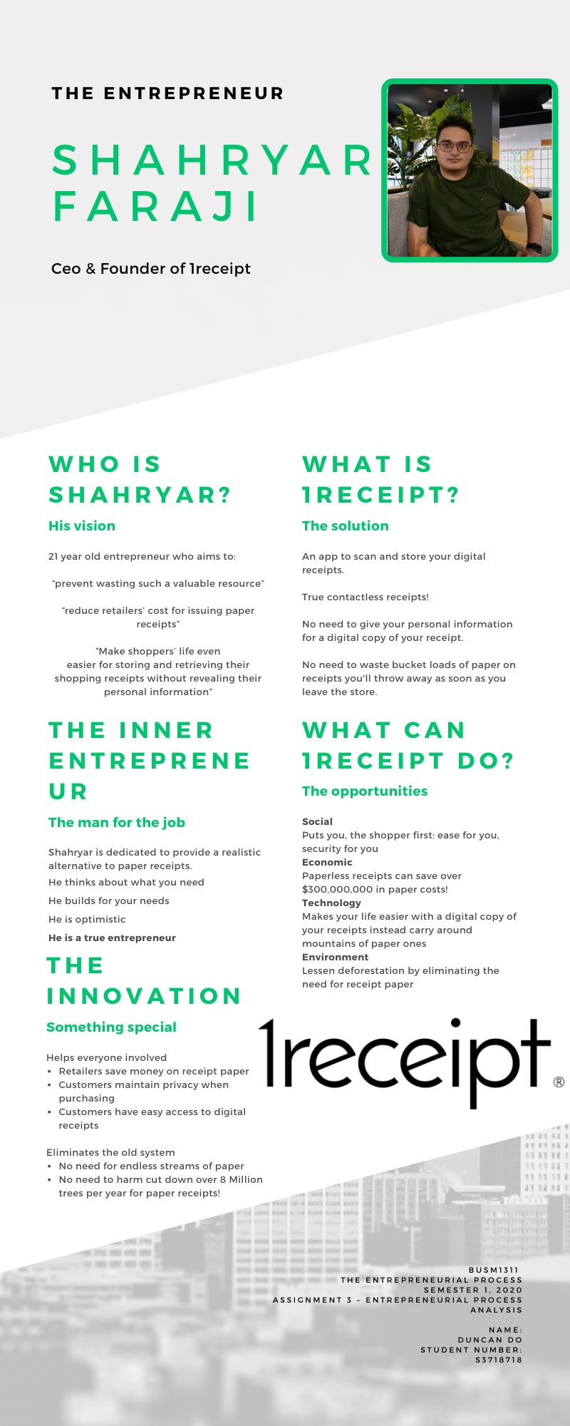

**Supporting Evidence Contents Page**

|  |  |
| --- | --- |
| Interview Questions and Transcript  Answers Recorded via survey format  Entrepreneur Business Card  Pictures  References | 13  22  23  IN REPORT |

Questionnaire Contents:

* 7 Sections
  + Section 1: 4 Questions
  + Section 2: 8 Questions
  + Section 3: 6 Questions
  + Section 4: 4 Questions
  + Section 5: 2 Questions
  + Section 6: 2 Questions
  + Section 7: 1 Question

**Section 1: Details**

1. **What is your full name?**

Answer: Shahryar Faraji

1. **What is your birthdate?**

Answer: 01/8/1998

1. **What is the name of your business?**

Answer: 1receipt

1. **Please provide some images for an infographic**
   1. **Picture of you:**

Answer: 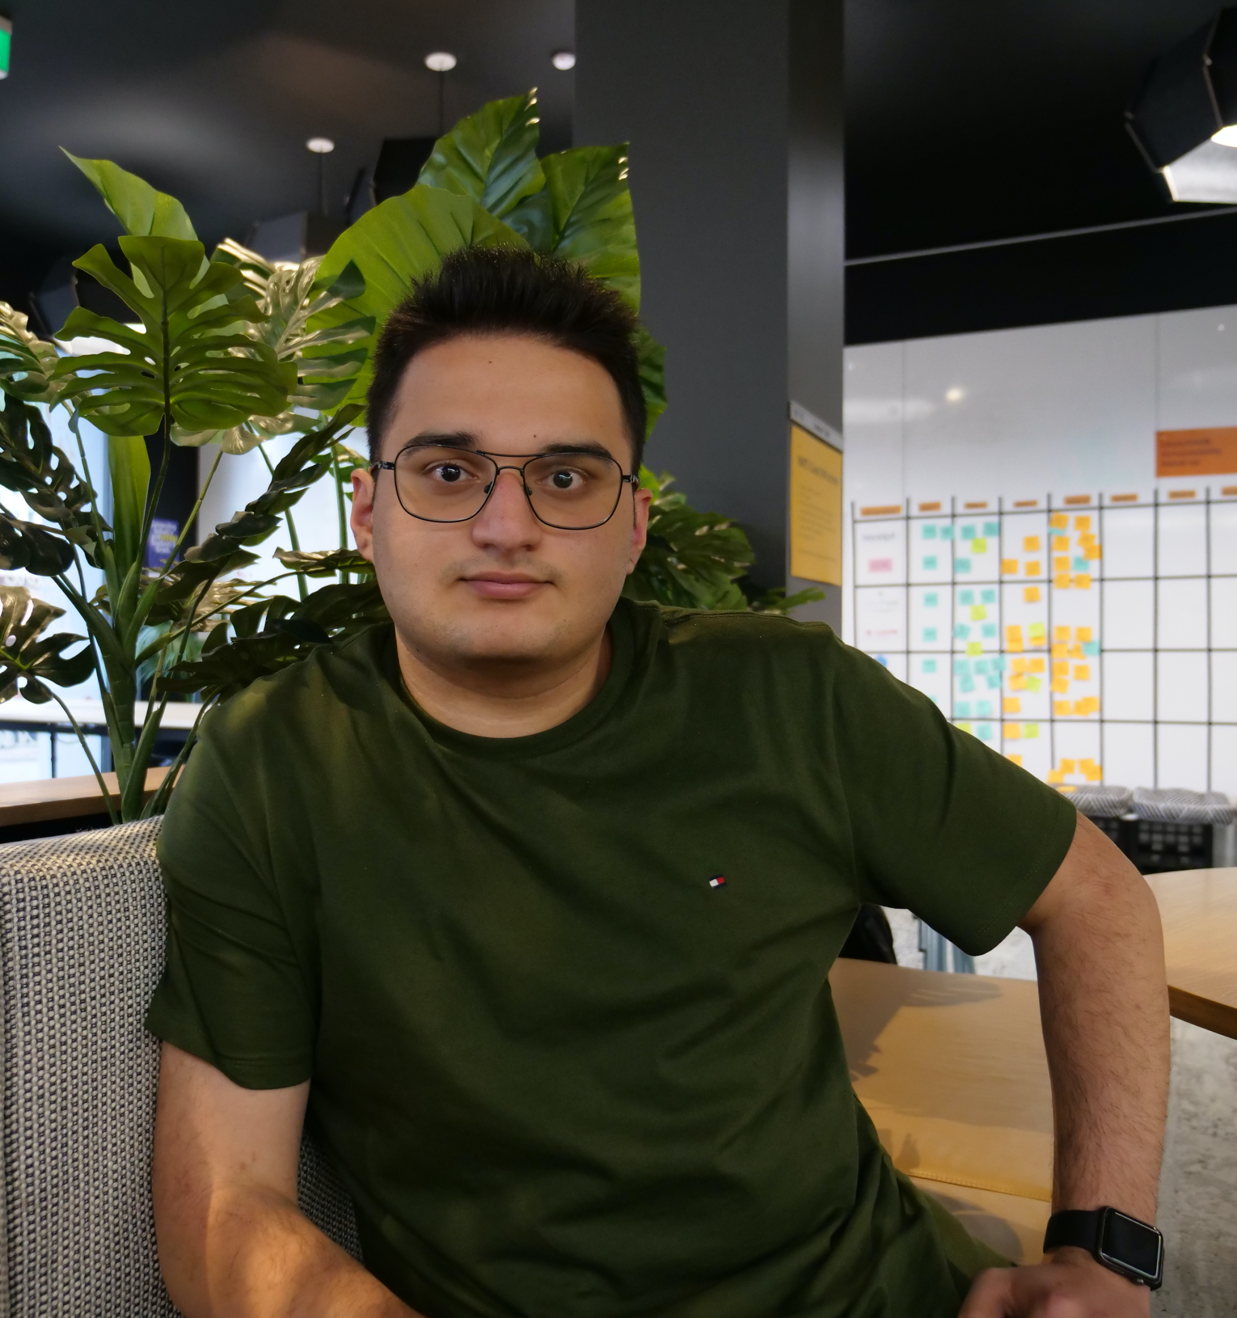

* 1. **Picture of your business logo:**

Answer: 

* 1. **Pictures of any promotional material you have for your business:**

Answer: 

Let me know if you need anymore. You can check our site also -> [www.1receipt.io](http://www.1receipt.io)

* 1. **Picture of your business location/place where you work (If able):**

Answer: LOL (it is RMIT Activator).

* 1. **Picture of your business card**

Answer: 

**Section 2: How the entrepreneur demonstrates the entrepreneurial mindset and the ethical dilemmas the entrepreneur faced**

1. **Which of the three statements do you and your business identify with most?**

|  |  |
| --- | --- |
| **1. A new innovation on the current status quo** | **(I.E. Creating something brand new to the market)**  **(E.G. The invention of the car/internet)** |
| **2. Disrupting the current status quo of your industry** | **(E.G. Uber disrupting the taxi industry)** |
| **3. Harmonizing supply and demand** | **(E.G. Opening a coffee shop in an area where none exist and there is a demand for coffee)** |

Answer: **2**

1. **Describe why you became an entrepreneur? (Specifically mention if it was for “Personal advancement”, “No alternative”, or “Independence”)**

Answer: Independence and unleashing creating to solve real world problem

1. **Subsequently, do you identify as an opportunity-driven entrepreneur or necessity driven entrepreneur?**

Answer: As an opportunity-driven entrepreneur

1. **Please select at least 3 of the following skills and give a quick example on how you demonstrated said skill**

|  |  |
| --- | --- |
| **Inner control** | **Decision making** |
| **Planning and goal setting** | **Human relations** |
| **Risk taking** | **Independence** |
| **Innovation** | **Reality perception** |
| **Use of feedback** |  |

Answer: Decision making - Making decision between what customers needed and what is the core feature of the product

Innovation - 1receipt project!

Risk taking - Try different methods for go to market strategies

1. **Which of these statements describes you with your business? (Provide a 1-2 sentence reason for each you select)**

|  |
| --- |
| **You identify other people’s needs.** |
| **You build a product that meets those needs.** |
| **You repeat until you get it right.** |
| **You are intensely committed.** |
| **You have a determined perseverance.** |
| **You are optimistic.** |
| **You are burning with competitive desire.** |

Answer: All

1. **Do you have a failure in your entrepreneurial journey that you learnt from? If so, what was it and what did you learn?**

Answer: Not yet :)

1. **Have you come across an ethical dilemma regarding your business? If so, what was it and how did you overcome it (If you did)?**

Answer: Nah

1. **Do you identify as a social entrepreneur? (Act as an agent of change - identifying a social problem and using their entrepreneurial skills for social and environmental goals)**

Answer:Not fully. I would say myself I am half of a social entrepreneur. Harder to find a solution for social problem.

**Section 3: Pathway/Venture Process he/she took to start the business**

1. **How did you come up with the idea of your business?**

Answer: Seeing people exiting shops or department stores while they are throwing away large pieces of white papers (shopping receipts) into the nearest bin inspired me to do a half- year-long research to find a solution to prevent wasting such a valuable resource as well as reducing retailers’ cost for issuing paper receipts and making shoppers’ life even easier for storing/retrieving their shopping receipts without revealing their personal information. I then realized that in Australia we must keep our receipts for at least 5 years for GST calculation and other tax purposes – a task which looks practically impractical due to the maximum one-year life span of the thermal paper receipts.

1. **Why did you start this business venture?**

Answer: To solve a big problem which was in the society:

* $350,000,000 paper receipt issuing cost - spent yearly by major retailers ONLY in Australia.
* Personal data sharing risk by Email / SMS receipts.
* 8,500,000 trees cut every year only for paper receipts.
* Serious health issue by touching paper receipts - which can cause cancer in our body [<http://shorturl.at/cjsNW>].
* Hard to convert shoppers into loyal members.

1. **Which entrepreneurial opportunity best describes why you started your business?**

|  |  |
| --- | --- |
| **Want to compete with the existing businesses (Purchase low, sell high)** | **Became aware of a gap in the market** |
| **Want to Innovate (And disrupt existing markets)** | **Social Needs identified (Want to address the social problem)** |

Answer: (((((((Want to Innovate)))))))

1. **Which of these bests describes the pathway of your business?**

|  |  |
| --- | --- |
| **1.Bootstrapping** | **Used other people's resources.**  **Rely on networks and existing resources** |
| **2.Business assistance funding** | **Had access to aid in your venture.**  **E.g. financial funding, business information, training, mentoring** |
| **3.Miniprenurship** | **Started as a niche market and then expanded norm commerce** |
| **4.Classic start-up** | **Began because of one of the following (If so, which)**  **1.Satisfy untapped demand**  **2.Andance the product frontier**  **3.Lower prices**  **4.Broader market penetration**  **5.Drive less innovative products out of the market** |
| **5.Achquiring an existing venture** | **Obtained someone else’s business** |
| **6.Social venturing** | **Driven by the want to find solutions to social injustice or environmental problems** |

Answer: Bootstrapping (Used code fragment bootstraps) Got my first prototype using mostly bootstraps.

Business assistance funding (Activator services and funds)

1. **Please identify some key phases in the process you took to begin your business**

Answer: Concept, ideation, building prototypes (many prototypes), building the MVP and delivering to the first customers for feedback and iterating over it.

1. **Did it follow this flow? (In some capacity)**

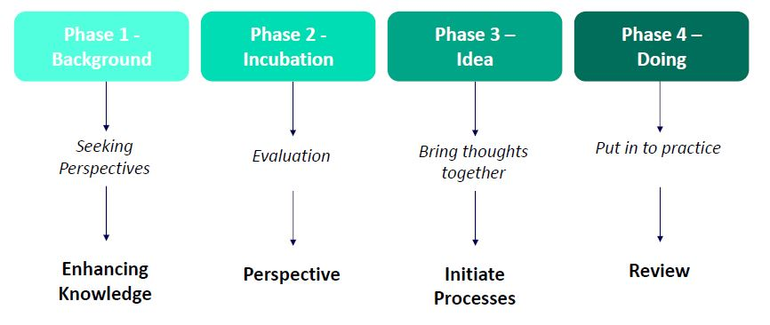

Answer: Yes.

**Section 4: How their business is innovative and helped the entrepreneur to be successful and why**

1. **Which best describes your business and its concept?**

|  |  |
| --- | --- |
| **1. Invention** | **Totally new product, service, or process** |
| **2.Extension** | **New use or different application of existing product, service, or process** |
| **3.Duplication** | **Creative replication of an existing concept** |
| **4. Synthesis** | **Combination of existing concepts and factors into a new formulation or use** |

Answer: Invention

1. **Describe how your business fits the category selected in question 1 of Section 4**

Answer:

* With 1receipt costless service, retailers will not need to waste millions of dollars on issuing paper receipts.
* With 1receipt, shoppers feel Cybersecured. No personal info sharing.
* Preventing cutting millions of trees every year for paper receipts with 1receipt.
* Providing true contactless receipt.
* Creating meaningful customer relationships at the point of sale.

1. **In your own words, how is your business innovative?**

Answer:

1receipt offers a dynamic and completely unique service that comes with countless benefits for both retailers and shoppers. Instead of helping *one* group of people, it benefits *everyone*. Retailers can save money by going digital where shoppers can keep their information safe and ultimately save their time.

The current standard of emailing or text messaging receipts is an ineffective way to eliminate paper receipts. We cut giving personal information out and give people the opportunity to check out faster at shopping centres.

1. **How has your business helped you to become successful?**

**Section 5: What opportunities did the entrepreneur perceive and exploit to develop their business in relation to the forces in the competitive environment**

1. **What hole in the market did you see that your business fills?**

Answer: Mentioned in my problems :)

1. **How is your business different from its competitors? (How does it stand out)**

Answer: 1receipt is give the power to the shoppers to not share any personal information to the retailer and just scan the app at the checkout to get a true contactless receipt. On the other side, we also help the retailers to save costs on issuing paper receipts and create a meaningful customer relationship at a point of sale.

**Section 6: Funding sources they obtained**

1. **What sources of income did your business obtain? (E.g. Self-funded, investors, government loans)**

Answer: Self-funded + funding from accelerator (Activator)

1. **How did you obtain said income sources?**

Answer: Personal contribution

**Section 7: Different approaches**

1. **Is there anything you would have done differently in your business venture? Looking in retrospect. If so, what?**

Answer: Yes, at the early stage get my validation done with actual customers paying for it before building anything.



**\*Due to COVID-19 social distancing restrictions, the entrepreneur and I were not able to meet up in person. Thus separate images of the entrepreneur, myself, and the location are supplied\***





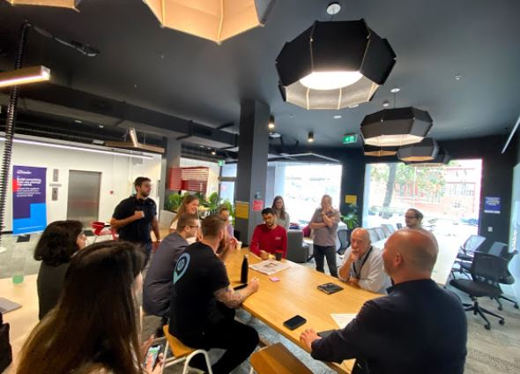

**RMIT Activator**